MAKEREREUNIVERSITY
COLLEGE OF COMPUTING AND INFORMATION SCIENCES
DEPARTMENT OF NETWORKS
BSSE
BSE 2301: RECESS TERM II
SOFTWARE DESIGN SPECIFICATION
PROJECT NAME: NATIONAL BASKETBALL ASSOCIATION ANALYSIS
SUPERVISOR: Mr. MBABAZI ISAAC

TEAM MEMBERS
NAME | REG NO. | STUD NO.
SAMIR HABIB | 16/U/11334/EVE | 216016914
OKOTH BRAIN | 16/U/10926/EVE | 216002929
CHEPKURUI JACOB ISAAC | 16/U/4608/EVE | 216016754
NIYONSABA ALEX | 16/U/10344/EVE | 216004565

A Software Design Specification for NBA Analysis System

By Group 21

Table of Contents
1. Introduction 5
1.1. Document Outline 5
1.2. Document Description 6
1.2.1. Introduction 6
1.2.2. System Overview 7
2. Design Considerations. 9
2.1. Assumptions and Dependencies 9
2.2. General Constraints 10
2.3. Goals and Guidelines 10
2.4. Development Methods 10
3. Architectural Strategies 10
3.1. Architectural styles 10
3.1.1. The client/server based architecture. 10
3.1.2. Server based architecture. 11
3.1.3. Cloud computing architecture 11
3.2. User interface 11
3.3. Security 12
3.4. Data storage 12
4. System Architecture 12
4.1. Primary Components 12
4.1.1. System High Level Collaboration Diagrams 13
5. Policies and Tactics 14
5.1. Coding guidelines and conventions 15
5.2. R studio 15
5.3. Design patterns 15
5.4. Test plan 15
5.5. Requirements traceability matrix 15
6. Detailed System Design 16
6.1. Client interface 17
Classification 17
Definition 17
Responsibilities 17
Constraints 17
Uses/Interactions 17
Resources 17
6.2. Controller 18
Classification 18
Definition 18
Responsibilities 18
Constraints 18
Uses/Interactions 18
Resources 18
Processing 18
6.3. DBMS interface 18
Classification 18
Definition 18
Constraints 18
Uses/Interactions 18
Resources 19
6.4. Help 19
Classification 19
Definition 19
Responsibilities 19
Constraints 19
Uses/Interactions 19
Resources 19
Processing 19
6.5. Admin 19
Classification 19
Definition 19
Responsibilities 19
Constraints 19
Resources 19
Processing 19
6.6. Dataset 20
Classification 20
Definition 20
Constraints 20
Uses/Interactions 20
6.7. Summary 20
Classification 20
Definition 20
Responsibilities 20
Constraints 20
Uses/Interactions 20
Resources 20
Processing 20
6.8. Prediction 21
Classification 21
Definition 21
Responsibilities 21
Constraints 21
Uses/Interactions 21
Resources 21
Processing 21
6.9. Relationship 22
Classification 22
Definition 22
Responsibilities 22
Constraints 22
Uses/Interactions 22
Resources 22
Processing 22
6.10. Comparison 22
Classification 22
Definition 22
Responsibilities 22
Constraints 22
Uses/Interactions 22
Resources 23
Processing 23
7. Glossary 23
8. References 24

Introduction
This is a guideline for the content of the various sections and subsections of the document. The document contains information got from many sources like the internet and previous software engineering documents.

Document Outline
- Document description
Introduction
System overview
- Design considerations
Assumptions and Dependencies
General constraints
Goals and Guidelines
Development methods
- Architectural Strategies
- System Architecture
Subsystem Architecture
- Policies and Tactics
- Detailed System Design
Classification
Definitions
Responsibilities
Constraints
Composition
Uses/Interactions
Recourses
Processing
Interface/Exports
Detailed Subsystem Design
- Glossary
Bibliography

Document Description

Introduction
- Document purpose
The purpose of this document is to describe overview of the architecture and system design of the NBA analysis system
- Document scope
Goal
To enable the document act as training information to the developers and new team members in the system development, therefore providing them with all the necessary information and understanding of the project.

Objectives
To provide the system developers with all the information necessary for development of the system
To provide an overview of the system to new developers
To develop a guideline for the system developers

Benefits
New members in the development team will be provided with information about the project they are working on.
A guideline of the project will be available for the system developers

- Document Audience
System Developers:
The developers will have a clear explanation and understanding of the system they are developing
- System Identification
NBA Analysis System
- Reference Material
http://www.cs.utah.edu/ /SDS.v2.htm
- Definitions/Terms
NBA: National Basketball Authority

System Overview
i) Product Perspective
This product is a data analysis based system. It will describe, accurately predict outcomes and identifies the relationships between data points from the NBA data set
Design Method
The products design will take on the procedural approach
User Interfaces
- The first time a user should see a login page. If he is not a registered member, he will be directed to the signup page.
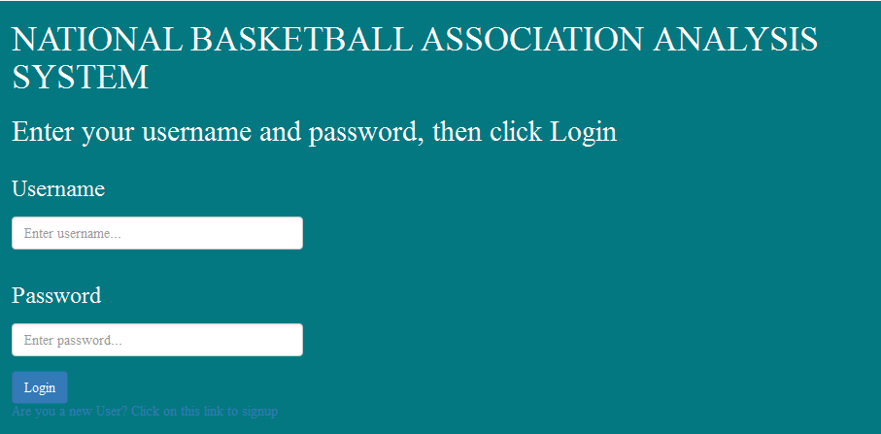

- Registered users, from the signup page will be directed to the home page which looks like this below.
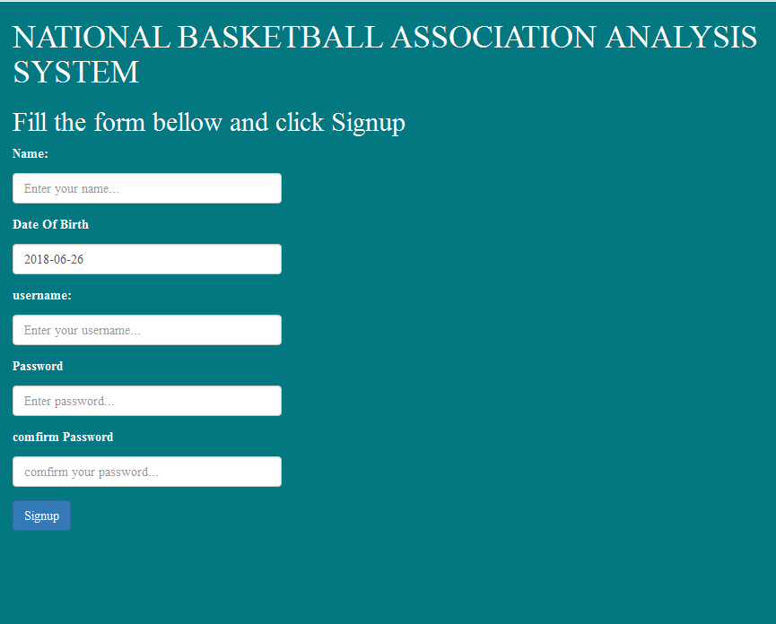

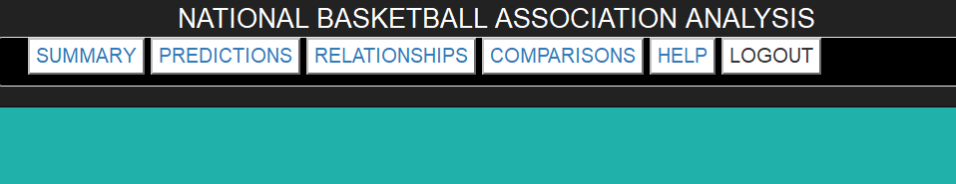
- The main buttons on the home page include: summary, predictions, relationships, comparisons, help and logout.

- Summary button, this directs the user to the page that enables him to see the summaries about the NBA data.
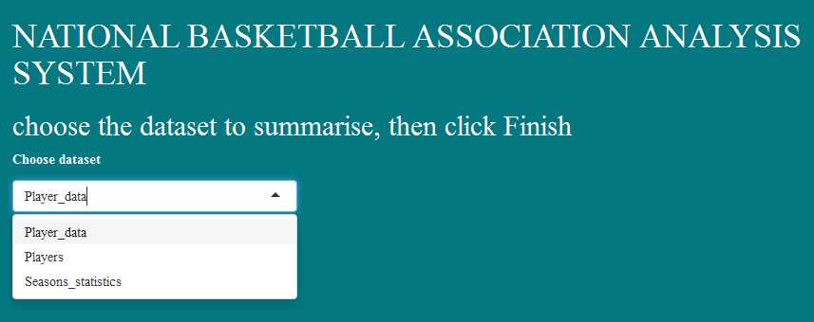
- Predictions button enables the user to make predictions basing on the NBA statistics.
- Relationships button enables the user to obtain relationships within the dataset
- Comparisons button enables the user to make comparisons from the dataset
- Help button directs the user to the instructions and guideline manual
- Logout button enables the use to sign out from the system

Hardware Interface
The system operates on any computer that has a windows operating system and a device that a browser that supports html
Software Interface
The system will use MySQL or Oracle data base and it will be implemented using R Studio
It will run on windows operating system
Memory Constraint
The machine on which the program can run must have a minimum of 2GB RAM and 500GB minimum of internal hard drive
Site Adaptation Requirements
This product is intended to execute on any windows platform with no modifications needed
ii) Product Functions
- This system should describe and summarize data
- It should identify the relationship and differences between variables in the data set
- It should compare variable
- It should predict the outcomes basing on the data set
- It should allow users to login and logout
iii) User Characteristics
NBA Officials:
They perform detailed analysis about all Basketball clubs. They are not expected to have a high educational and proficiency level or technical expertise in data analysis
Club Managers:
They perform detailed analysis about their clubs. They are also not expected to have a high educational and proficiency level or technical expertise in data analysis
System Administrators:
They provide access to the system resources. He/she is expected to have technical expertise in data analysis
iv) Constraints/Operating Environment: The system will operate on a computer with Windows operating system. And the computer should have R Studio installed.
v) Assumptions and Dependencies it’s assumed the system being developed will work correctly with R Studio since it will be developed in R.
vi) User documentation
- A user manual will be provided.
- Online help via an email will be provided.

Design Considerations.

Assumptions and Dependencies

- The system will provide a graphical user interface for the client machines implemented using shiny in R programming language.
- The system will be running on the windows operating system.
- The system depends on the available datasets to create statistics in order to come up with the summaries, predictions, etc.
- The user has basic knowledge on the operations of the client machine, which is a personal computer in this case.
- The users of the system are aware of the basic operations of a computer and webpages
- The user understands the standard terms used for operations.

General Constraints
- The system is built accessible only by authorized personnel, who have to register in order to get access
- The system is implemented using R programming language
- The clients will only be able to use the system when connected to the internet.

Goals and Guidelines
- Modularity and functional separation: Ensuring that data in one’s user account cannot be accessible to other users.
- Ensuring that the clients only get access to abstract features that are only important to them.
- Where possible, use known software design patterns and employ software best practices.
- Other than network errors, no internal software failures are acceptable.

Development Methods
The system is developed with flexibility for further development or modification. The system is divided into manageable processes that are grouped to sub-modules and modules that are built with abstraction. The project will be divided into modules which will be implemented by the team members.

Architectural Strategies

Architectural styles

The client/server based architecture.
- The client/server architecture was selected because it can link the NBA dataset to the server which can be accessed by the client computer via the internet or the association’s intranet. The architecture also has got different application logic layers that help the users and the administrator with complex processing tasks.
- This architecture was considered because it has a high processing speed which is facilitated by the programs and data that travels on an internal system which moves data more efficiently.
- The architecture supports an improved response time for example when a user clicks any command, the system will be capable of responding in real time.
- The client/server architecture is more secure that is to say servers have better control access to ensure that only authorized users can access or manipulate the data and server-updates are administered effectively.
- The architecture enables easy maintenance without affecting the clients of the system. Here the system can be upgraded or repaired without inconveniencing the users.
Other architectures that were considered but not used:

Server based architecture.
- This was not selected because it requires expensive hardware compared to client/server architecture. The architecture requires expensive network operating system software and the client license. The architecture requires a dedicated network administrator.
- In case the server goes down, the entire system is likely to go down because all the clients are server dependent.

Cloud computing architecture
- This was not selected because it is internet based implying that the services cannot be accessed in the absence of internet connection. The architecture also doesn’t address privacy issues. The poor internet may also slow down data accessibility hence poor performance.
- It is also vulnerable to attacks since every item can be accessed through the internet. There is limited control and flexibility.
- Offers limited control to the association’s data since cloud infrastructure is entirely owned by the service provider, it transfers minimal control to the customers. In this case the association cannot control the backend infrastructure itself.

Architectural Diagram
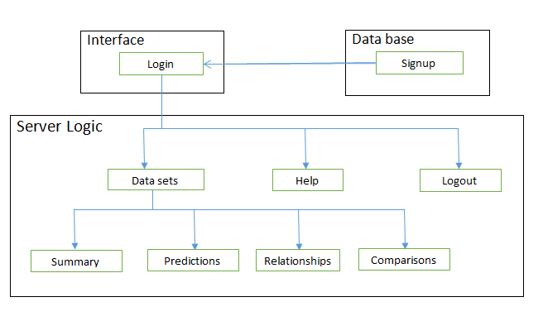

User interface
- The NBA analysis application requires a graphical user interface for all users that is to say the system administrator and the other stakeholders.
- One of the design constraints is to use R as the major programming language and R studio as the programming environment. R shiny package will be used in the development of the graphical user interfaces.
- The system will use the NBA datasets as the inputs perform some computations on the data and in turn outputting a number of results.

Security
- Users of the NBA analysis system will be able to login to system with their usernames and passwords.
- Those without whose login details are not in the system shall be able to sign up to the system.

Data storage
- User login details shall be stored in the database while the data used for the various analyses shall be stored in the csv format.

System Architecture
The NBA analysis system will be partitioned into components of major functionality and responsibilities.

Primary Components
The high-level system architecture for NBA analysis system, including its components is shown in this subsection.

System High Level Collaboration Diagrams

Login
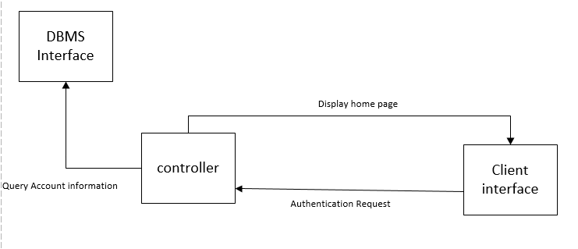
Client interface: R Studio or browser in use by the user.
Controller: Initial point of contact for requests before log-in.
DBMS interface: retrieves and stores data for login details.

Dataset summary, predictions, Relationships and comparisons
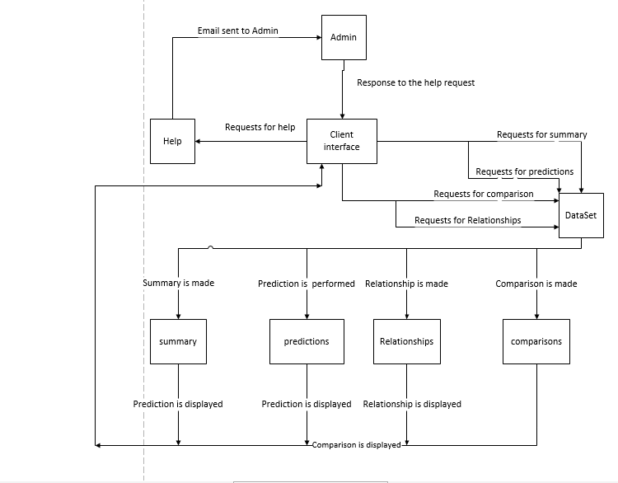
Help: allows the user to contact the admin for help.
Dataset: NBA datasets.
Summary: a component for summarizing the datasets.
Predictions: A component for making predictions
Relationships: A service for finding relationships between variables within the dataset.
Comparisons: a component for comparing variables within the datasets.

Policies and Tactics

Coding guidelines and conventions
The project source code implementation will follow a standard R programming language convention. These conventions will include indentation, comments, statements, declarations, whitespaces, naming and programming practices.

R studio
The system will be developed using R programming language and a compatible version of R studio will be used.

Design patterns
The implementation of the system will take up the Predictive model form which consists of the following that is to say, input variables, variable selection algorithm, variable transformation, model features, functional form, induction algorithm, fitness function, fitting algorithm.

Test plan
The system shall be tested using the unit testing and integration test methods. Here we shall be able to test the smallest unit of the verifiable software in the application and also combine individual software modules and test them at once.
The system will be tested by a group of four members.
Testing shall be done when all the system requirements have been implemented.
Test environment, the system will be tested on windows operating system with a various sets of test data inputs.

Requirements traceability matrix

Requirements source | Requirements | Design element | Code function | Test case
Module 1  User can be able to make summaries about the NBA datasets. | Summarize data | Use case diagram | summary | Ensure that the data is always available.  Ensure that the system summarizes the data selected.
Module 2  Users can be able to obtain relationships between different data variables | Relationships between data. | Use case diagram | relation | Ensure that the system plots a number of graphs that can display the different relationships.
Module 3  User can make comparison between different players and teams. | Comparisons between different data variables. | Use case diagram | compare | Ensure that the system displays the statistics of individual players and teams.
Module 4  Both users and the system administrator can access the help page | The administrator can edit the help page while the other users can be able to view the help page. | Use case diagram | help | Ensure that only the administrator can edit the help page.
Module 5  Users can predict different occurrences based on the datasets. | Making predictions | Use case diagram | predict | Ensure that the system can make the required predictions
Module 6  Both the users can be able to log into the system and also logout | Security measurements | Use case diagram | Login | Ensures that the users login with their correct credentials.  Once the user logout he or she cannot access the home page without logging in again.

Detailed System Design

This section describes the purpose and architecture of NBA analysis system's major components. The tables included will provide more details on each component.

Client interface
Classification | Browser or R Studio software.
Definition | Allows a user to send requests.
Responsibilities | - It should allow users to send requests  - It should display users’ password.
Constraints | The computer will have at least 2GB RAM
Uses/Interactions | - This component interacts with Help to request for help.  - It interacts with the admin to provide help.  - It interacts with the controller to check login details.  - It interacts with the dataset to request for a summary, predictions, relationships and comparisons.  - It interacts with summary, prediction, relationship and comparison to display them.
Resources | Computer

Controller
Classification | Function.
Definition | It checks users’ login details.
Responsibilities | - It should allow access to authorized users.  - It should deny access to unauthorized users.
Constraints | It will be implemented in R language.
Uses/Interactions | - This component interacts with DBMS interface to get users’ login information.  - It interacts with Client interface to get login requests.
Resources | Sql data base that stores user’ login details.
Processing | - Sql query will be sent to the DBMS  E.g.  SELECT * FROM users WHERE username =”” && password=””.  - Then the user’s details will be valid.  - if they are valid access will be granted, else access will be denied.

DBMS interface
Classification | Sql database
Definition | It stores users’ login information.
Constraints | It will be implemented in Sql.  It will run on windows, Linux and Mac operating systems.
Uses/Interactions | - It is interracted by the controller to obtain login details.  - It interacts with Client interface to get login requests.
Resources | A computer.

Help
Classification | Module.
Definition | It allows a user to send a help request.
Responsibilities | - It should allow users to ask for help.
Constraints | It will require mail applications such as Gmail.
Uses/Interactions | - It is interacted by the client interface  - It sends an email to the Amin.
Resources | Mail applications such as Gmail.
Processing | - It sends a help request to the admin via an email.  - Then the Admin provides help by responding to the email.

Admin
Classification | System’s administrator.
Definition | He provides help to users.
Responsibilities | - It should receive an email from the user who is requesting for help.  - He should provide help by responding to the email.
Constraints | He should have technical expertise in data analysis.
Resources | Mail applications such as Gmail.
Processing | - He receives an email from the user.  - Then he provides help by responding to the email.

Dataset
Classification | NBA data sets.
Definition | It contains three datasets (player data, players and season statistics).
Constraints | Datasets will be changed after every season.
Uses/Interactions | - This component is interacted by client interface requesting for a summary, prediction, relationship or a comparison.  - It interacts summary, prediction, relationship or comparison components to make them.  - It displays summary, prediction, relationship or comparison to client interface.

Summary
Classification | Function.
Definition | It summarizes the dataset.
Responsibilities | - It should display a summary of the dataset in the client interface.
Constraints | It will be implemented in R language.
Uses/Interactions | - It interacts with dataset to make a summary.  - It interacts with Client interface to display the summarized data.
Resources | NBA datasets.
Processing | - A user requests to make a summary.  - The summary function is run  - The summarized data is then displayed in the client interface.  .

Prediction
Classification | Function.
Definition | It provides forecasts about the dataset.
Responsibilities | - It should display the prediction results in the client interface.
Constraints | It will be implemented in R language.
Uses/Interactions | - It interacts with dataset to make a prediction.  - It interacts with Client interface to display the prediction results.
Resources | NBA datasets.
Processing | - A user requests to make a prediction.  - The prediction function is run  - The prediction results are then displayed in the client interface.  .

Relationship
Classification | Function.
Definition | It finds relationships between variables within the dataset.
Responsibilities | - It should plot graphs in the client interface to indicate relationships.
Constraints | It will be implemented in R language.
Uses/Interactions | - It interacts with dataset to find relationships.  - It interacts with Client interface to plot different graphs.
Resources | NBA datasets.
Processing | - A user requests to find a relationship between variables of the dataset.  - The relationship function is run  - A graph indicating the relationship is then displayed in the client interface.  .

Comparison
Classification | function
Definition | It finds the comparison between variables within the dataset.
Responsibilities | - It should display the results in the client interface.
Constraints | It will be implemented in R language.
Uses/Interactions | - It interacts with dataset to get the comparison.  - It interacts with Client interface to display comparisons.
Resources | NBA datasets.
Processing | - A user requests to get comparisons between variables of the dataset.  - The comparison function is run  - The results are then displayed in the client interface.  .

Glossary
Csv: comma-separated-values. This is data that is separated by commas.
DBMS: Database Management System
NBA: national Basketball Association. In charge of Basketball related affairs in the country.
RAM: Random Access Memory
SDS: Software Design specification.

References
- http://capricorn.bc.edu/bi204/wp-content/uploads/2015/08/Chapter-14-2015.pdf

- https://geant3.archive.geant.org/Media_Centre/Media_Library/Media%20Library/GN3-09-185_Software_Architecture_Strategy_Best_Practice_Guide_4%200.pdf

- http://www.construx.com/Software_Design_Specification/#Design%20Considerations
- https://www.cs.utah.edu/d~drcannon/project/SDS.html

- http://www.construx.com/Software_Design_Specification/#Policies%20and%20Tactics

